Name________________________________ Date __________
Mr. Tallman Math 7-8 A
Do Now
In the space below, list as many opposites as you can think of.

Lesson #1 – Integers and Absolute Value
Use the key words in the word bank below to fill in the ovals in the graphic organizer. You may put more than one word in each oval.
Word Bank
Opposites | Positive Numbers | Negative Numbers | Whole Numbers

Understanding Integers

Let’s review positive and negative numbers:
Use the Venn diagram below to record what you know about positive and negative numbers.
Positive Numbers
Negative Numbers

**___________________________ is neither positive nor negative**
Negative | Positive
Integer Concepts
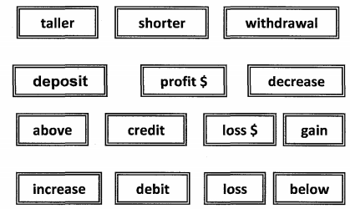
Sort out each word below into either the positive or negative column.

Now, You Try!
Write an integer to represent each of the following situations.
1) a loss of $200 ____________________ | 2) 85 feet below sea level ____________________
3) a deposit of $150 ______________________ | 4) a withdrawal of $20 _______________________

Absolute Value
The absolute value of an integer is ______________________________________________________________.
- The distance from 0 to 5 units $\left|5\right|$ = ___________

- The distance from 0 to – 5 units $\left|-5\right|=$_________
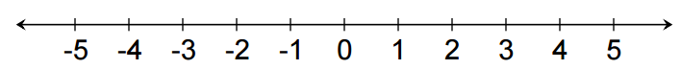

Can absolute value ever be negative? Justify. ____________________________________________________
________________________________________________________________________________________________________
Now, You Try!
Simplify the following:
5) $\left|-8\right|=$ __________ | 6) $\left|6\right|=$ __________ | 7) $-\left|-8\right|=$ __________

Compare the following using $<, >or=$.
8) $\left|-2\right| __________-1$ | 9) $-7____________\left|6\right|$ | 10) $9_____________\left|-9\right|$

Math in the Real World
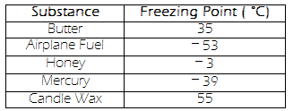
10) Is the freezing point of airplane fuel or candle wax closer to the freezing point of water ($0°)$? Explain your reasoning.
_________________________________________________________
__________________________________________________________
__________________________________________________________
__________________________________________________________

