Name________________________________ Date __________
Mr. Tallman Math 7-8 A
Do Now
Write the opposite of each number on the lines below.
1) $3$ _____________ | 2) $-28$ _____________ | 3) 42 _____________

Evaluate each absolute value.
4) $\left|17\right|=$ | 5) $\left|-9\right|=$ | 6) $-\left|-5\right|=$

Write an integer for each situation.
7) You go up 8 floors on an elevator. ________ | 8) You dive 200 feet into the ocean. _________
Lesson #2 – Adding Integers Using a Number Line
Recall:
- Integers are __________________________________________________________________________________.

- The zero on the number line is called the _______________________.

- Zero is neither ___________________ nor ______________________.
Example 1)
- Model the expression $-2+(-4)$ on the number line below.

- Repeat the process from part (a) and model $\left(-4\right)+\left(-2\right)$

What do you notice about the two sums from parts a and b? ____________________
Do think order matters when adding numbers? ___________________
Example 2) The temperature was $2°$ below zero. The temperature then drops by $5°$. What is the temperature now?
- What is the original temperature
written as an integer?_____________

- Mark the temperature on the number line

- A drop in temperature of $5°$ is like adding
______________ to the temperature.
Count the number line to find the final temperature.
- What is the temperature written as an integer? __________

The temperature is now _______ degrees above/below zero.
Example 3) Model the expression $4+\left(-3\right)$ on the number line below.

Example 4) Model the expression $-7+5$ on the number line below.

Now, You Try! Model each sum below on the number line.
5) $-3+(-1)$ | 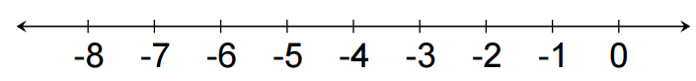  6) $-4+(-3)$
7) $3+(-4)$ | 8) $-5+2$
9) A football team receives a 5 yard penalty on one play and a 10 yard penalty on the next. Write a sum of negative integers to represent this situation. Then use the number line to evaluate the expression.

10) Suppose you received $10 dollars from your grandmother for your birthday. You spent $4 on snacks. Using addition, how would you write a mathematical expression to express this situation. Then use the number line to evaluate the expression.
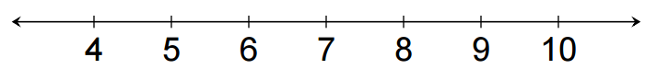

Challenge:
David and Victoria were playing a card game. David drew three cards, -6, 12, and -4. What is the sum of his cards? Model your answer on the number line below.

