Name________________________________ Date __________
Mr. Tallman Math 7R
Do Now
Evaluate the following.
1) $6+8$ | 2) $-512+512$ | 3) $37+\left(-5\right)$
4) $-43+20$ | 5) $-9+3+\left(-12\right)$ | 6) $6+\left(-2\right)+\left|-4+1\right|$

7) The New York Jets started out at the 30 yard line. Ryan Fitzpatrick throws a 15 yard pass, but on the next play, the Jets receive a false start and have to take a 5 yard penalty. What yard line are the Jets currently on? Write an expression to model this situation.

Lesson #4 – Subtracting Integers
Let’s remember the addition rules for integers:
Adding Integers: Same Sign | Adding Integers: Different Sign

Let’s discover the rule for subtracting integers:
Model the following problem on the number line below: $5-3$

Rewrite $5-3$ using an addition expression: $5-3\underset{→}{}$ ______________
If you reverse the order of integers, 3 – 5, will you get the same answer? Explain.

Rule for Subtracting Integers

Example 1) Change each subtraction problem into an addition problem. Then evaluate each.
A) $-7-2$ | B) $-1-(-3)$
C) $3-5$ | D) $-8-(-4)$

Example 2) Evaluate each expression if a = 9, b = $-8$ and c = $-2$
A) 14 – b | B) c - a

Example 3) The temperature on Monday was $-5°$C. By Tuesday, the temperature rose to $-2°$C. Write an expression to show the change in temperature. Then state the change in temperature.

Now You Try!
For questions 4-6 , evaluate the expressions when x = -5 and y = 7
4) $x-(-8)$ | 5) $-3-y$ | 6) $y-x-3$
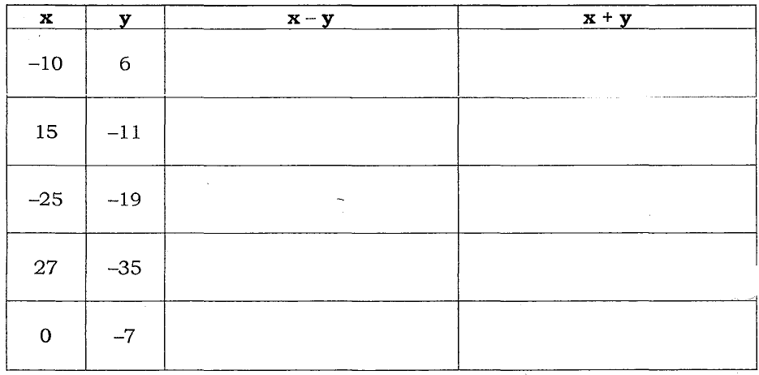
5) Complete the table below.

6) The top of a sailboat mast is 22 feet above the water’s surface. The bottom of the sailboat is 3 feet below the surface of the water. What is the difference in elevations?

7) The temperature at the start of a football game was $-1°F$. At halftime, the temperature was $-9°F$. What was the change in temperature?

8) A submarine is 450 feet below sea level. If it descends 300 feet, what is its new position?

